CoE - Tutorial 3

- Fred currently works for a corporate law firm and his annual salary is $125,000. He is considering opening his own legal practice, where he expects to earn $200,000 per year once he gets established. To run his own firm, he would need an office and a law clerk. He has found the perfect office, which rents for $50,000 per year. A law clerk could be hired for $35,000 per year. If these figures are accurate, is it advisable for Fred to open his legal practice?

- Assume you own and manage your own fruit stand. The financial information for the stand is given below (all values are monthly).
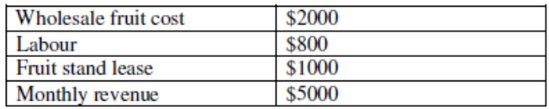
Answer each of the following, based on the information provided.
  - Calculate your accounting profit.
  - If your other employment opportunity is to earn $1000 per month working at a t-shirt stand (and you are equally happy selling fruit or t-shirts), what is your economic profit? Should you continue selling fruit? Explain.
  - What happens to your economic profit if you enjoy selling t-shirts and would be willing to forgo up to $250 per month to work selling t-shirts rather than fruit? Should you continue selling fruit? Explain.

- Adam operates a small shop specializing in party favors. He owns the building and supplies all of his own labor and money capital. Adam incurs no explicit rental or wage costs. Before starting his own business Adam earned $1,000 per month by renting out the store and earned $2,500 per month as a store manager for a large department store chain. Because Adam uses his own money capital, he also sacrificed $1,000 per month in interest earned on U.S. government treasury bonds. Adam’s monthly revenues from operating his shop are $10,000 and his total monthly expenses for labor and supplies amounted to $6,000. Calculate Adam’s monthly accounting and economic profits.

- You are to receive Rs 10,000 at the end of 2nd year and Rs 15,000 at the end of 5th year for an investment of Rs 20,000 right now. Is the investment profitable? Assume a discount rate of 7% per annum.

- Exactly ten years from now Sri Chand will start receiving a pension of `3,000 a year. The payment will continue for sixteen years. How much is the pension worth now, if Sri Chand’s interest rate is 10 per cent?

- Your father has promised to give you Rs 100,000 in cash on your 25th birthday. Today is your 16th birthday. He wants to know two things: (a) If he decides to make annual payments into a fund after one year, how much will each have to be if the fund pays 8 per cent? (b) If he decides to invest a lump sum in the account after one year and let it compound annually, how much will the lump sum be?

SOLUTION 4 FORMULA -→ACTUALLY QUESTION NAMING TUTE 5
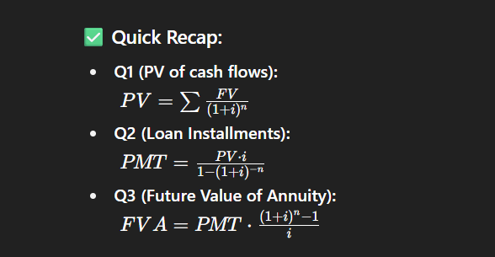

SOLUTION 5 FORMULA
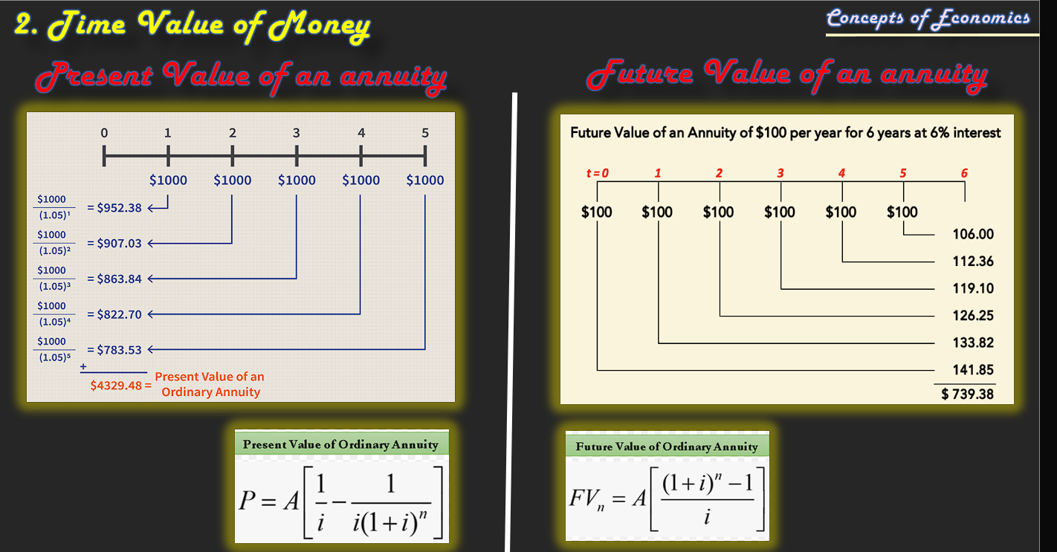

ANS6 